**PyCitySchool Data Analysis**

Observable Trends

**Students’ Scores by School Type:**

Here (figure 1) is student’s math and reading scores analysis by “School Type”. It is obvious from the below analysis that:

1. Charter Schools students in math scored almost 7% more scores and in reading scored 3+ % more scores than District Schools.
2. Similarly, Charter Schools math passing rate is whooping 27+% more and reading pass out rate is 16% more than Districts Schools.
3. Overall passing rate of Charter Schools is much higher than the Districts Schools.

In short Charter School students are not only performing better in average math and reading scores but also are showing much higher rate of passing.

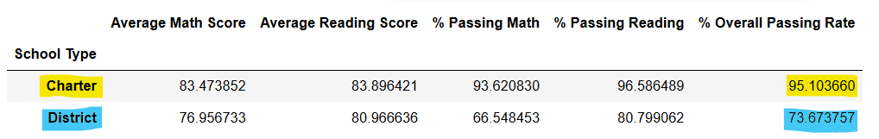

Figure 1

**Students’ Scores by School Size:**

Here (figure 2) is student’s math and reading scores analysis by “School Size”. It is obvious from the below analysis that:

1. Smaller School students on the average are scoring higher scores in math and reading. Difference between Smaller to Medium School student’s scores is less significance than difference between Medium to Large School students.
2. Trend we observed in math and reading scores between Small to Medium schools and Medium to Large schools is more obvious in math and reading passing rates. Again, difference between Small to Medium is much less than the difference between Medium to Large size schools.
3. By looking at the overall passing rate it is noted that Small School students passing rate is about 4% more than the Medium School students pass out rate whereas Medium School students passing rate is more than 17% higher than the Large School students pass out rate.

In short smaller the school size better the students scores and passing rate is.

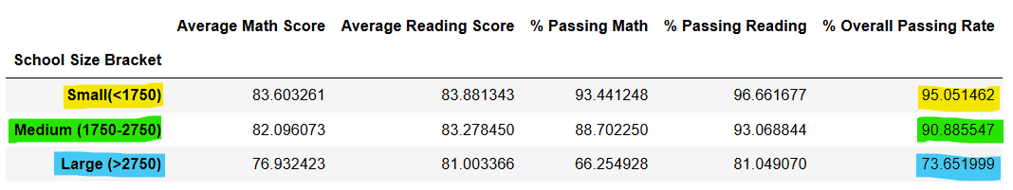

Figure 2